Reporting on Section 6
Community and Town Councils

Environment (Wales) Act 2016 Part 1 – Section 6
The Biodiversity and Resilience of Ecosystems Duty

The Biodiversity and Resilience of Ecosystems Duty
Report 2025
Name of Community or Town Council: | Nash Community Council
Group: | 3
Introduction and Context
Nash Community Council serves the small rural village of Nash, in Newport, South Wales. The Council covers a small population (estimated under 500 residents) and has an annual precept of £4,137.
The Council manages Nash Village Hall, a key community facility surrounded by public green space maintained by Newport City Council. Less than a mile away lies the Newport Wetlands Reserve, an important ecological site forming part of the Gwent Levels landscape.
The Council’s direct influence on biodiversity is limited, as most grounds maintenance and verge management are undertaken by Newport City Council and local farmers. However, it plays a key role in supporting biodiversity-related initiatives through its facilities and partnerships, for example, hosting RSPB workshops as part of the Living Levels project.
This is the Council’s first formal Section 6 report under the Environment (Wales) Act 2016, following the resignation of the Clerk, Previous reporting records have not been located. The Council intends to embed the Section 6 duty into its future decision-making and to strengthen its role in promoting biodiversity awareness through its community facilities and partnerships.

Action Report 2023 - 2025
NRAP  Objective | Action carried out to… |  | Monitored by:
1 | -embed biodiversity into decision making & procurement | • Used eco-friendly cleaning products in the hall.  • Encouraged recycling and waste separation through dedicated bins (food, cans, plastic, cardboard, etc.).  • Ensured hedge cutting behind hall is carried out between October and March to avoid disturbing nesting birds.  • Uses solar panels on the hall | Booking Clerk/Chair/Vice chair
1 | -raise awareness of biodiversity & its importance | • Intend to add an environmental clause to future contracts and hire agreements.  • Will review hall consumables annually to ensure sustainable sourcing. | Chair/Vice Chair
2 | -safeguard principal species and habitats | • Ensured hedge cutting, mowing, or tree work takes place outside the nesting season. | Chair/Vice Chair
3 | -restore & create habitats and resilient ecological networks | • No dedicated projects to date.  • Intend to introduce small biodiversity features such as a bird box or pollinator planter in 2025–2026 | Chair/Vice Chair
4 | -tackle negative factors: for e.g. reduce pollution, use nature based solutions, address invasive species | • Promoted recycling and waste reduction at community events.  • Encouraged hirers to minimise single-use decorations.  • Incorporated recycling checks into the cleaning schedule to improve compliance. | Booking Clerk/Chair/Vice chair
5 | -use improve and share evidence | • Intend to liaise with RSPB Living Levels and Newport City Council to share biodiversity information and updates.  • Will encourage residents to engage in citizen science and wildlife recording initiatives. | Chair/Vice Chair
6 | -support capacity and/or other organisations | • Hosted RSPB workshops as part of the Living Levels project.  • Will continue to make facilities available for environmental and educational use by partner organisations where possible. | Chair/Vice Chair

Review of S6 duty actions for 2023-2025
What has worked well? | The Council’s biodiversity awareness has improved significantly during this reporting period. Hedge-cutting continues to be carried out responsibly between October and March to avoid disturbance to nesting birds, and the introduction of recycling facilities at Nash Village Hall has encouraged event hirers and the public to separate waste more effectively. Eco-friendly cleaning products are now used as standard within the hall.
What have the barriers been? | The main challenge has been ensuring that hall hirers correctly separate recyclable materials. While a bond retention system has been introduced to promote compliance, effective monitoring remains difficult. To address this, recycling checks have now been incorporated into the hall’s cleaning schedule.
What will you change? | The Council will build on the progress made by adding a short environmental clause to future contracts and hire agreements, trialling small biodiversity features such as a bird box or pollinator planter.
How and when will the s6 duty be monitored and the s6 plan reviewed? | Progress will be reviewed annually at a Council meeting each March and formally reported every three years in line with the national Section 6 reporting cycle. The Council will publish the latest report on its website and make printed copies available upon request

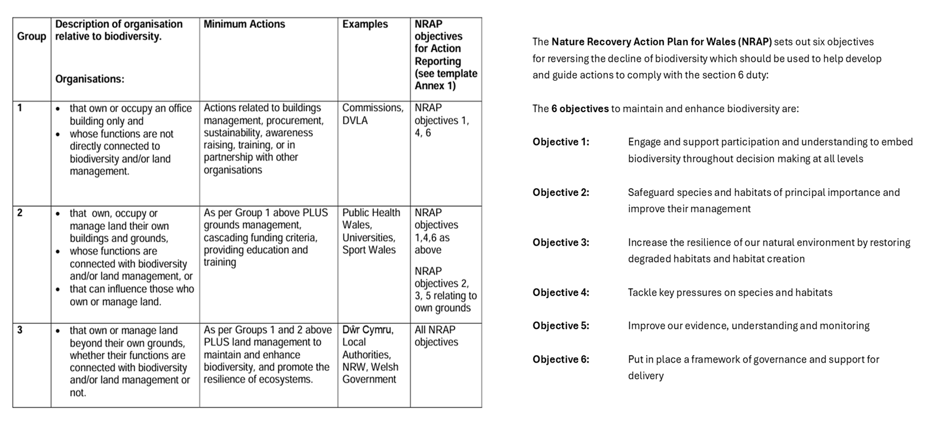
Back

Adrodd ar Adran 6
Cynghorau Tref a Chynghorau Cymuned

Deddf yr Amgylchedd (Cymru) 2016 Rhan 1 – Adran 6
Y Ddyletswydd Bioamrywiaeth a Chydnerthedd Ecosystemau

Adroddiad 2025
Ddyletswydd Bioamrywiaeth a Chydnerthedd Ecosystemau

Enw y Cyngor Tref neu Gymuned:
Grŵp:
Cyflwyniad a'r Cyd-destun
- Disgrifiad byr o'r Cyngor, ei swyddogaethau a'r cyd-destun o ran
- sut y gallai helpu bioamrywiaeth (trwy ei swyddogaethau rheoli tir, cyllid grant, gweithgareddau addysgol e.e.)

- graddfa ofodol a lle (e.e. faint o dir mae'n ei gynnwys, poblogaeth, praesept?)

- cyflawni gwasanaethau i'r cyhoedd (e.e. a yw'n destun Ddeddf Llesiant Cenedlaethau'r Dyfodol?)
Adroddiad Gweithredu 2023 - 2025
Amcan NRAP | Camau gweithredu i... |  |  | Wedi eu monitro gan:
1 | -cynnwys bioamrywiaeth o fewn llunio penderfyniadau a chaffael
1 | -codi ymwybyddiaeth o fioamrywiaeth a'i bwysigrwydd
2 | -diogelu prif rywogaethau a chynefinoedd
3 | -adfer & chreu cynefinoedd a rhwydweithiau ecolegol cydnerth
4 | -mynd i'r afael ag elfennau negyddol: lleihau llygredd e.e. defnyddio atebion yn seiliedig ar natur, mynd i'r afael â rhywogaethau goresgynnol
5 | -defnyddio gwella a rhannu tystiolaeth
6 | -cefnogi capasiti ac/neu sefydliadau eraill

Arolwg o ddyletswydd Adran 6 2023 - 2025
Beth sydd wedi gweithio'n dda?

Beth fu'r rhwystrau?
Beth fyddwch yn ei newid?
Sut a phryd fydd y ddyletswydd Adran 6 yn cael ei monitro a'r cynllun Adran 6 wedi'i adolygu?

Nôl
